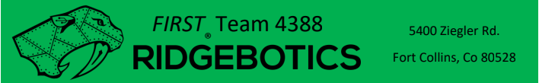

Sponsorship Information
Business Name: Contact Person: Address: City: State: Zip Code: Phone: E-mail: Business Website:

Thank you for your support!

Student Contact: Alex Melby (Business lead)
- Email: addiemelby@gmail.com
Contact: Joe Aurand
- Email: joseph_aurand@hotmail.com

Your generosity is greatly appreciated and will be put to good use!

Website: Ridgebotics.com Team Email: ridgebotics@gmail.com

